LAB 11
A Taste of Data path + Control Design Example:
Factorial Circuit ( Open Ended Lab )
Objective :
To implement a circuit that calculates factorial of a number.
Block Diagram:
The datapath for calculating the factorial of an “N” bit number is
given below. The datapath is controlled by a Finite State Machine (FSM). FSM
generates signals Asel, Ale, Bsel and Ble at the correct times to operate the
datapath. Input to FSM is a signal “Z” when Z=0 means the operation of the
machine is complete and ANSWER can be read. The STG is also given in the
following diagram.
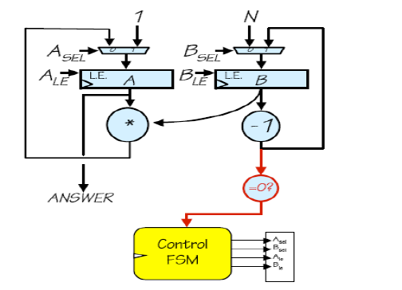
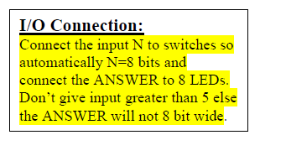
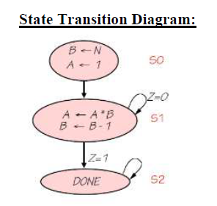

Task 2: Implement Multiplication for repeated addition using data path and control path (FSM)
Note: you can do simulation as well

